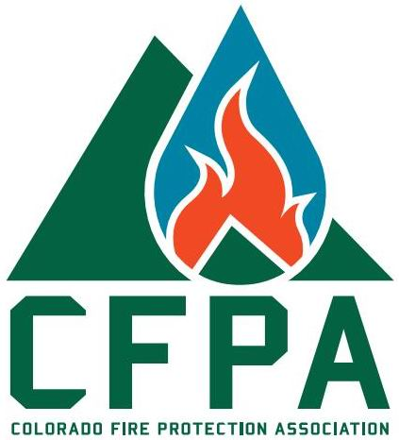
Wednesday
September 18th, 2019
7am – Breakfast Meeting
Great Scott’s Eatery
1295 Cortez St. Denver CO

CFPA Meeting
State of Colorado Division of Fire Prevention & Control
&
West Metro Fire

Please join CFPA in Welcoming Rob Sontag and Chuck Altvater with Division of Fire Prevention & Control. Chuck and Rob will be presenting an overview of the Division of Fire Prevention & Control jurisdictional boundaries, Electronic plan submission process, New personal, upcoming events, Code updates, Licensing updates, Suppression Rules.
Bruce Kral with West Metro Fire with be speaking about the Compliance engine for inspections that many of the AHJ have been going to in the recent months.

Do you have questions/comments for this meeting?
CFPA@CoFireProtection.org
ISPACE IS LIMITED – RSVP REQUIRED
CFPA@CoFireProtection.org
WHEN: Wed 09/18/19
TIME: 7:00 am
PRICE: $25 pre-paid/RSVP
RSVP: CFPA@CoFireProtection.org Great Scotts Eatery
Secure online payment: http://mkt.com/cfpa Highway 36 & Pecos

